BUSINESS REQUIREMENT DOCUMENT

<<Communication Journey: Placement Process in CRM>>

<<Dhawal Sah>>

<<Aravind Ravi Sankar>>

**VERSION: 1.0**

DATE <<2022-05-24 >>

**TABLE OF CONTENTS**

**1.1 Problem Statement/ Requirement Background** **3**

**1.2 Current Solution/Process (if any)** **3**

**1.3 Related Documents** **3**

**1.4 Solution Scope** **3**

**1.5 Constraints** **3**

**1.6 Business Goals and Objectives** **3**

**1.7 Priority** **3**

**1.8 Target User/ User Community** **3**

**1.9 Impact Analysis** **4**

**1.10 Additional Information** **4**

**1.11 Stakeholder consultation** **4**

**1.12 Approvers** **4**

### 

### 1.1 Problem Statement/ Requirement Background

What are the current problem statements faced by the Business owner?

Currently the whole Placement Process is being communicated manually to all the stakeholders. And as the number of aspirants are increasing this would be difficult to track

Provide a brief introduction to the project. This includes describing the business context of the project and the users.

Presently we have features for adding jobs for an aspirant. Also we can update the progress of an aspirant in each round. Schedule Call is a feature used to schedule aspirant and HR interviews. But there are no communication journeys attached to it. Placement POCs have to manually mail all the aspirants, HRs, Career Coaches and Placement Gls regarding the status of an aspirant in various stages of Placement.

### 1.2 Current Solution/Process (if any)

Describe the current environment as it relates to the solution scope for this document. Does the client have an existing solution? What is it? What are some of its key challenges? What is being done manually?

Currently the following features are available on CRM regarding the Placement process of an aspirant:

* Add Job: Used to add companies in which an aspirant’s resume in shared
* Update in Job List: Used to update the status of an aspirant in various Rounds.
* Options in update button: Used to Select the aspirant round, option to check whether aspirant attended the interview and final option to select whether aspirant was accepted or rejected in a certain round
* Schedule in Job List: Used to Schedule Interviews of an aspirant with HR.
* Final Disposition Change: Used if an aspirant is placed and also options to select whether an offer letter is received and whether the aspirant has accepted the offer letter.

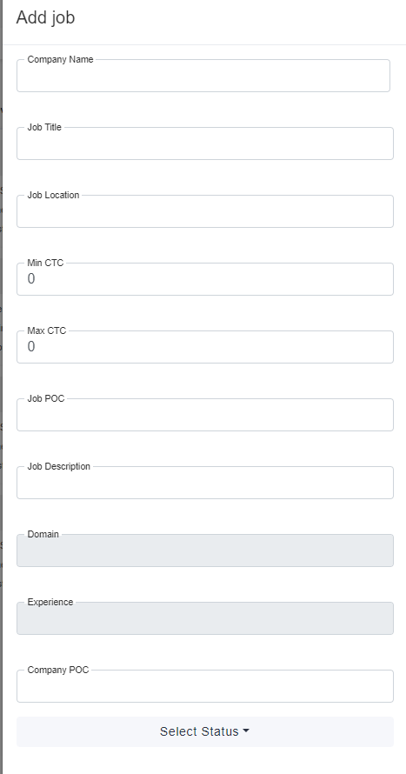

**Add Job Feature**

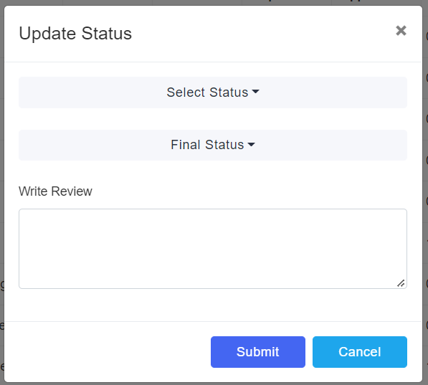

**Update in Job List**

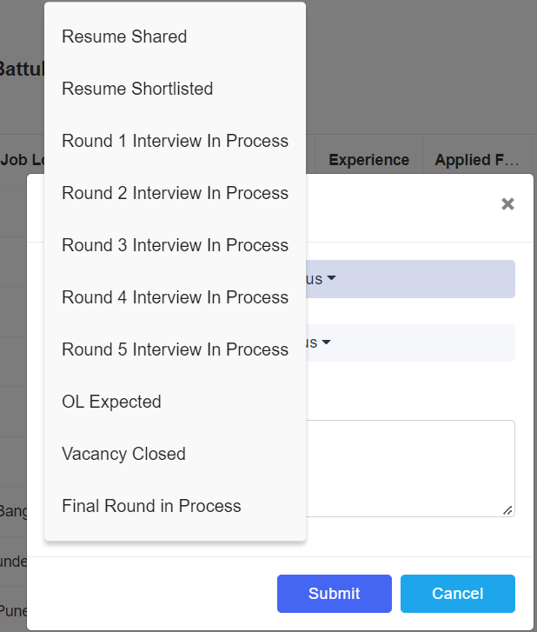

**Options in Update Button**

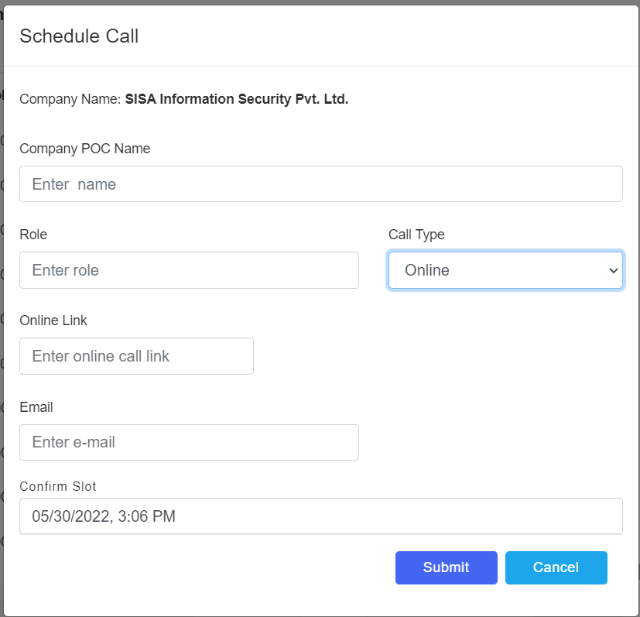

**Schedule in Job List**

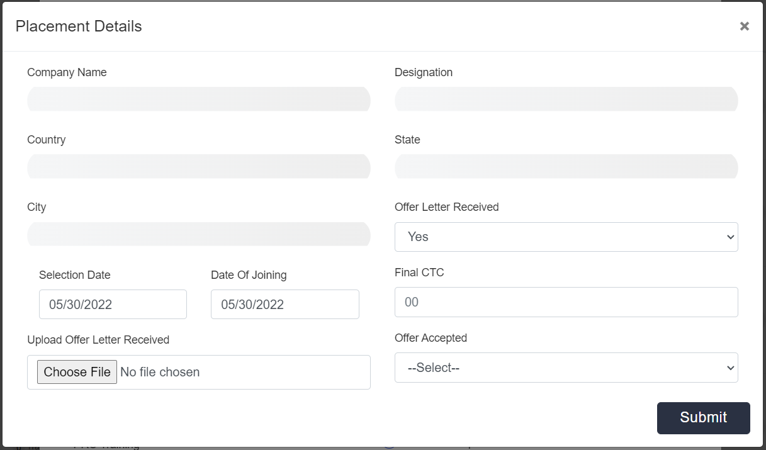

**Final Disposition Change**

Some of the challenges include:

* Aspirants not getting notified automatically over various stages in the placement process
* Aspirants are manually notified of their Interview on the scheduled day
* HRs and POCs are not automatically notified of aspirants interview on the scheduled day
* Placement GLs are unaware of the aspirants status
* Placement POC has to send mails manually for every process in an aspirant’s placement round.
* HR’s are not reminded to release offer letters
* Aspirant’s decision on offer letter not communicated to Career Coaches, Placement GLs, HR, etc.

Currently, the following are being done manually

* POC manually mails/ calls both the aspirants and Career Coaches regarding the status of aspirant in the placement pool
* POC has to manually remind HR and aspirants through mails and calls
* POC manually has to notify Career coach of an aspirants interviews through mails
* POC has to manually remind HR to release offer letter

If the current solution has financial impacts, provide a high-level description.

### 1.3 Related Documents

Reference any business deliverables/documents associated with this requirements document.

Some emails which I have referred to prepare the Communication content:

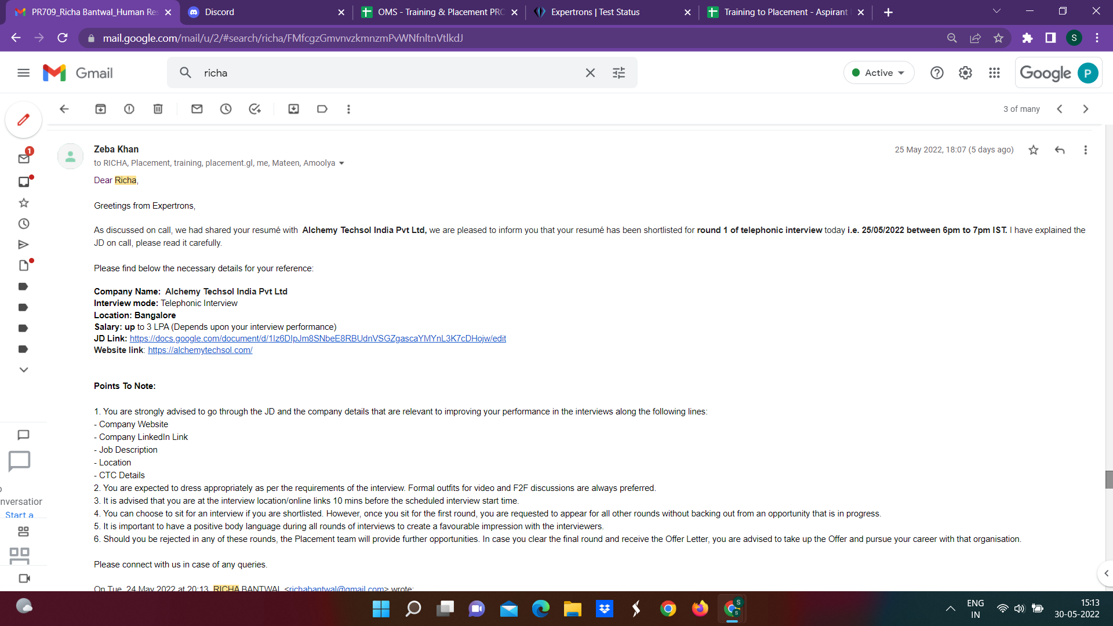

**Resume Shortlisted**

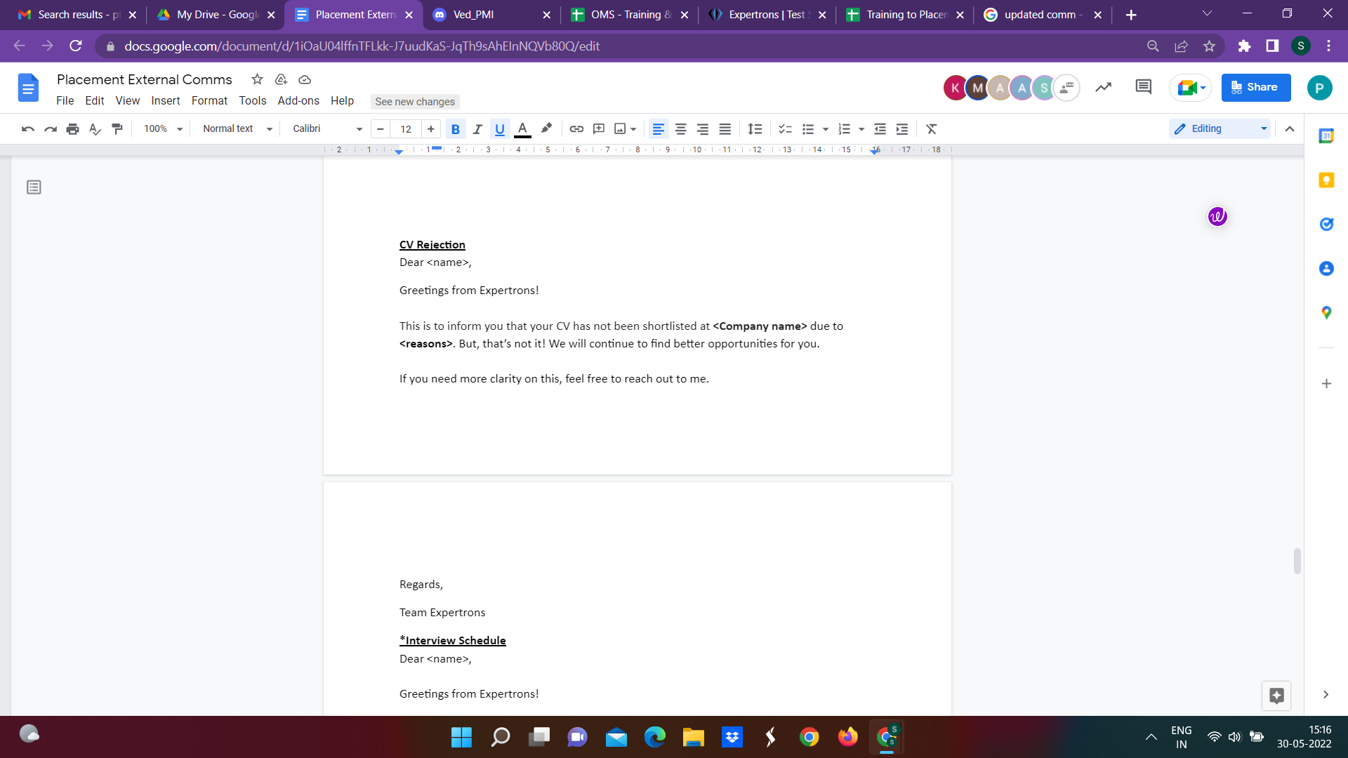

**Resume Not Shortlisted**

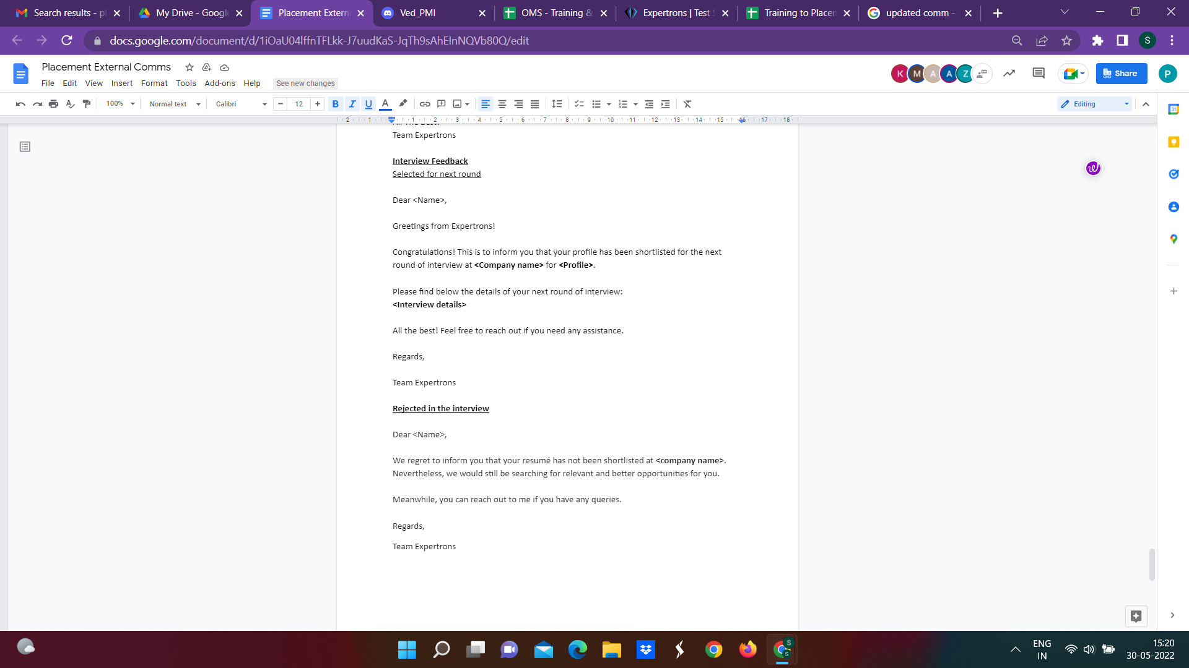

**Shortlisted For Next Round**

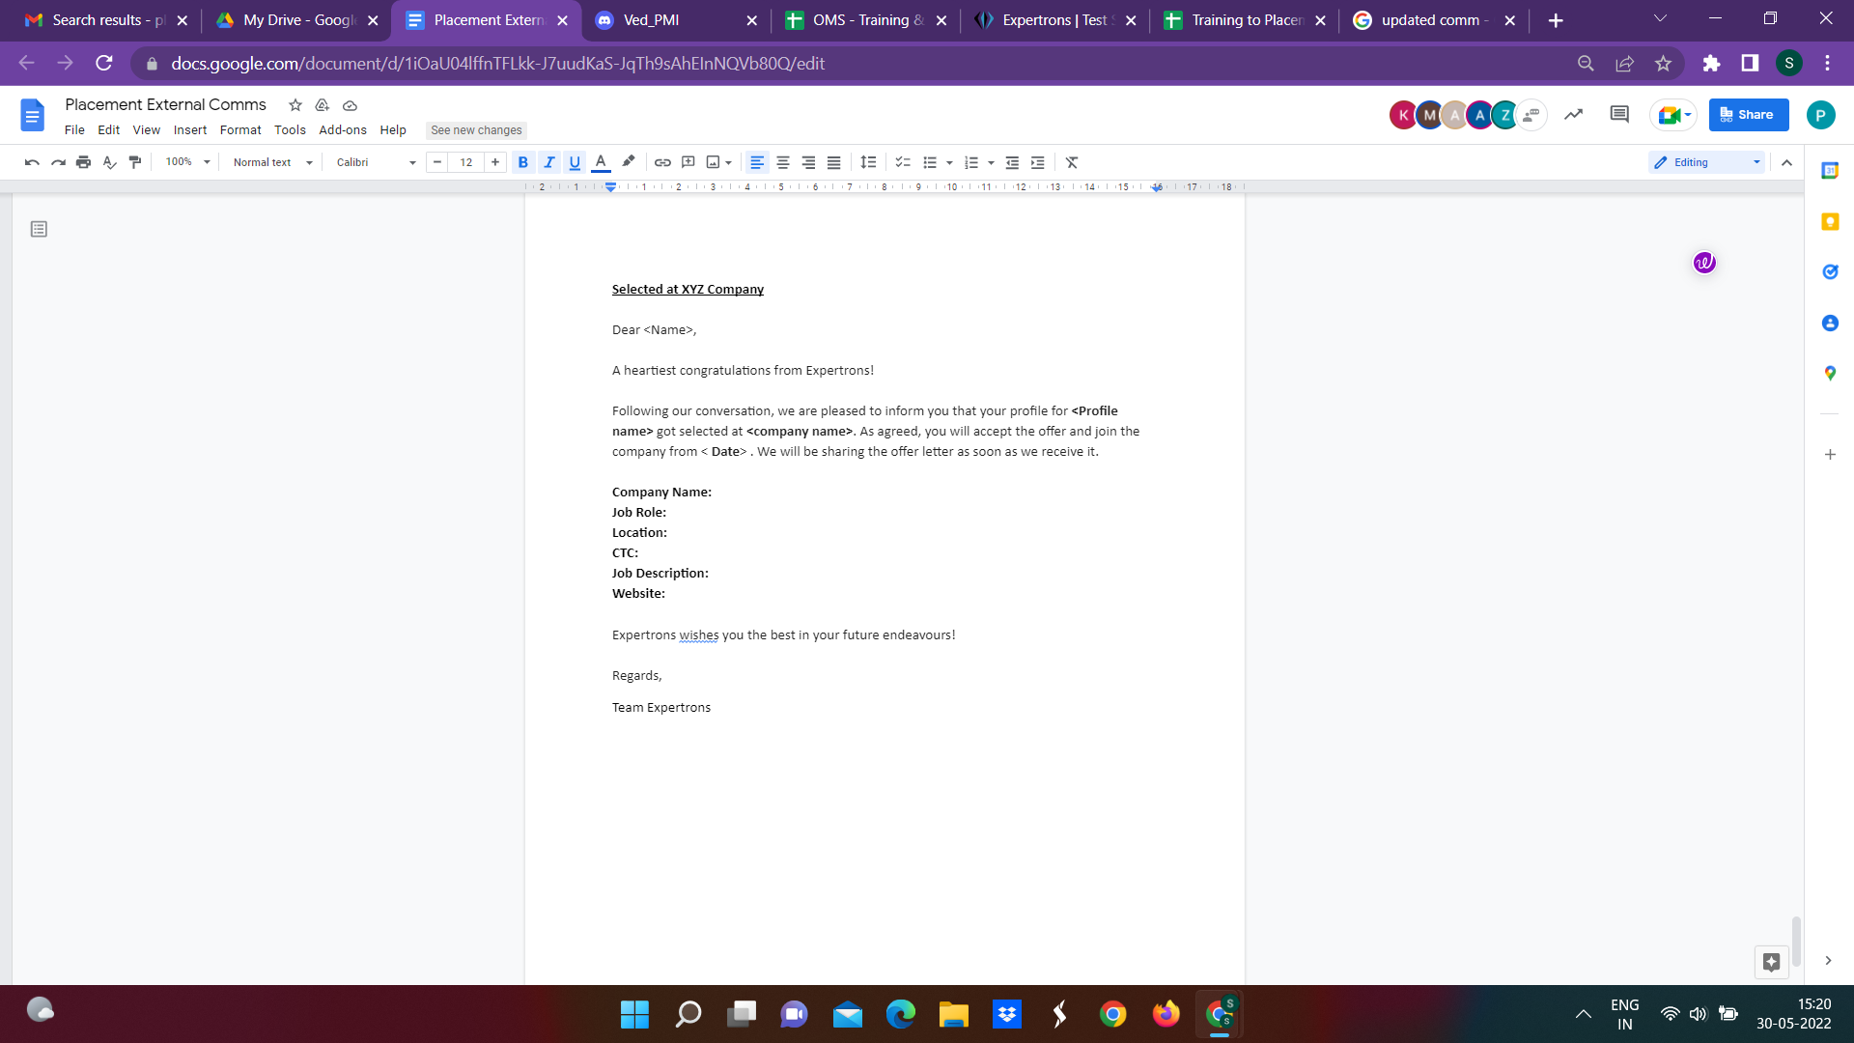

**Placed at XYZ Company**

### 1.4 Solution Scope

Define the scope of the solution that this document describes. Indicate any components no longer in scope (e.g., scope changes from that described in the Preliminary Scope document).

Business Needs are of an automated Communication Journey for the Placement Process features having the following components:

* automated mails to aspirant notifying him of his/her status in any round
* automated mails to Career Coaches and Placement GLs notifying him/her of the aspirant’s status
* automated mails to aspirant regarding Offer Letter acceptance/ rejection
* automated mails to Career Coaches and Placement GLs notifying them of an aspirants decision of acceptance/rejection of any offer letter
* automated mails to Placement POCs so that they are kept informed at every status change and interview processes
* The status changes include Aspirant’s acceptance/rejection in a specific interview round or any resume sharing process.
* Addition of an Attendance feature in the Update Button of Job Process to notify aspirant of his/her attendance in the interviews.
* Also mails regarding the attendance of an Aspirant in an interview would be sent to all the concerned stakeholders (Aspirant,Career Coaches, Placement POCs and GLs)
* Reminder mails being sent to HR and POCs regarding HR not releasing Offer Letter.

Detailed Breakdown of these priorities: [Placement Journey - Features & Priority List](https://docs.google.com/spreadsheets/d/15HCm2JdLe-0_Sq2UXw51KjGX58O_URqNFSWPRSeMemo/edit#gid=0)

### 1.5 Constraints

What are the business goals and objectives we are trying to achieve with this project

### 1.6 Business Goals and Objectives

What are the business goals and objectives we are trying to achieve with this project

Implementing a Communication Journey to the Placement Process would be highly beneficial for Placement POCs because:

1. POCs have to perform a lot of manual work of sending emails to aspirants regarding every process in their placement journey.
2. Also Career Coaches and Placement GLs need not be informed through manual mail. All this work once automated would lead to better efficiency, less errors and less workload of POCs.
3. Would increase the bandwidth of POCs and also less error in the system since everything is automated now.
4. POCs themselves are being informed on every step of the process therefore it would be very easy to keep track of a single aspirant.
5. Reminder mails are also implemented in the system which would lead to less time spent in achieving any task.
6. Associated authorities are requested through mails to make follow-up calls at special situations. Thus the system would be highly efficient and error-free.

### 1.7 Priority

Use the following three categories to prioritize requirements (do not introduce and mix other prioritization methods such as the MoSCoW method):

* **High** to indicate a solution element that is critical to the client’s business function and operation;
* **Medium** to indicate a non-critical solution element that provides significant benefit to the client; and
* **Low** to indicate a non-critical solution element that provides a helpful or convenient feature that is beneficial to the client.

Detailed Breakdown of these priorities: [Placement Journey - Features & Priority List](https://docs.google.com/spreadsheets/d/15HCm2JdLe-0_Sq2UXw51KjGX58O_URqNFSWPRSeMemo/edit#gid=0)

### 1.8 Target User/ User Community

If applicable, identify all possible user groups for the solution.

For each user group, estimate the number of users and reference the functional areas each will need access to.

All the Aspirants currently involved in the Placement Pool

All the HRs whose companies are onboard in the Placement Pool

All the Placement POCs, Career Coaches and Placement GLs

### 1.9 Impact Analysis

How is this product/feature

### 1.10 Additional Information

Include any information related to the requirement (e.g., hyperlinks to related online content). Where appropriate:

* Reference the associated business process model within the *Business Process Definition* document; and
* Identify the owner (e.g., source) of the requirement.

Communication Journey should include the following:

* Email Content - [Link](https://docs.google.com/spreadsheets/d/15HCm2JdLe-0_Sq2UXw51KjGX58O_URqNFSWPRSeMemo/edit#gid=0) (Doc links provided in the sheet)
* Flowthrough - [Link](https://docs.google.com/spreadsheets/d/15HCm2JdLe-0_Sq2UXw51KjGX58O_URqNFSWPRSeMemo/edit#gid=0) (Flowchart Sheet)
* Placement POC Journey through CRM: - [Link](https://docs.google.com/spreadsheets/d/15HCm2JdLe-0_Sq2UXw51KjGX58O_URqNFSWPRSeMemo/edit#gid=0) (POC Flowthrough Sheet)

**Additional Features**

There are some additional features which need to be added for the smooth functioning of communication Journey. Also these features are necessary for better tracking of aspirants in the placement process.

1. Attendance tracking dropdown menu - An attendance tracker should be made to track the attendance of aspirants in interviews. A representation of this feature is given below:

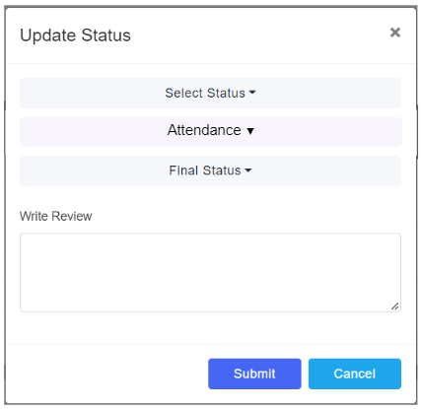

1. This should be a dependent menu. Attendance drop down should have three features: Attended, Not-Attended and Not-Attended: Rescheduled. Also this menu should not be visible in all cases.
2. Some cases like: Resume Shared, OL Expected should not have this attendance feature. A detail list of such features is given in the [Link](https://docs.google.com/spreadsheets/d/15HCm2JdLe-0_Sq2UXw51KjGX58O_URqNFSWPRSeMemo/edit#gid=0)
3. On Selection of Rejected as Final status, The Update button should be blocked as the process for this company is over.
4. On Selection of Resume Rejected, The Update button should be blocked as the process for this company is over.
5. A dropdown to select the Round for which Interview is scheduled in the Schedule Interview Card.
6. Addition of a new selection in Call Type dropdown: “Face to Face”. On Selection of this field, two new fields should be displayed: “Interview Location” and “Interview Phone No.”
7. Also if the Round does not match in Schedule and Interview Status cards then a pop-up would be displayed asking to select the same round in both the Cards

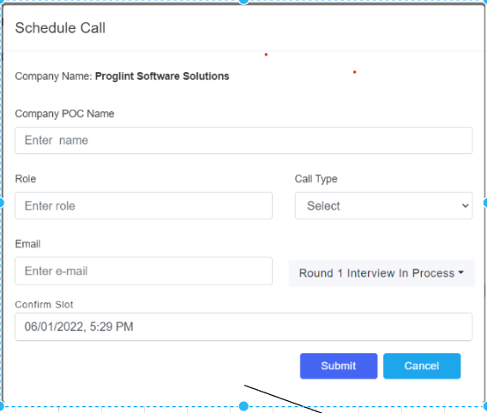

1. Interview
2. Also on selection of “Not Attended” in attendance should always block the Final Status Button as, an aspirant who does not attend the interview, is rejected anyways.

A detail process map of POC user is given below: [POC Flowthrough](https://drive.google.com/file/d/12MmE5XGSLBvBwjvihi2G03Pzsir0tQ4t/view?usp=sharing)

**1.11 Stakeholder consultation**

Identify the stakeholders for the solution and for the project, what their role(s) are, and whether they were consulted.

| **Stakeholder Name** | **Role** | **Consulted** |
| --- | --- | --- |
| Simran Merchant | Assisted in understanding the whole placement procedure and the adoption of features on CRM | Yes |
| Siddharth Nautiyal | Conveyed all the CRM features and also assisted me in understanding the Communication Journey | Yes |
| Aravind Ravi Sankar | Assisted in finding use cases and trigger points for various communication journeys | Yes |

### 

### 

### 

### 1.12 Approvers

The following individuals have approved the financial requirements on the date indicated.

| **Approver Name** | **Role** | **Approved** |
| --- | --- | --- |
|  |  | << Yes / No >> |
|  |  | << Yes / No >> |
|  |  | << Yes / No >> |